# PyLab 1: Raspberry Pi, Debugging a Python Internet of Things Application

Follow me on Twitter [@dglover](https://twitter.com/dglover)

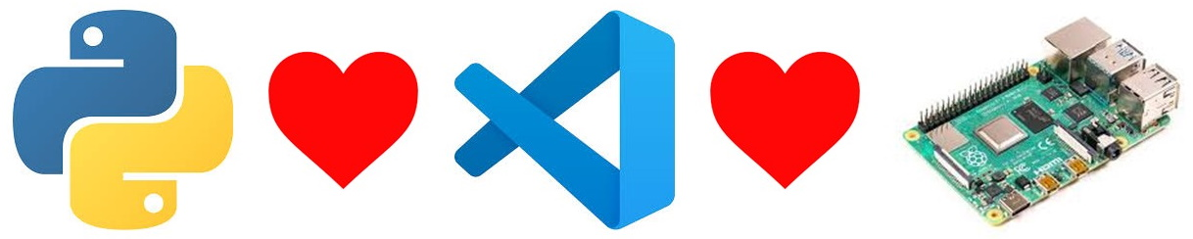

banner

|  |  |
| --- | --- |
| Author | [Dave Glover](https://developer.microsoft.com/en-us/advocates/dave-glover?WT.mc_id=pycon-blog-dglover), Microsoft Cloud Developer Advocate |
| Platforms | Linux, macOS, Windows, Raspbian Buster |
| Services | [Azure IoT Central](https://docs.microsoft.com/en-us/azure/iot-central/?WT.mc_id=pycon-blog-dglover) |
| Tools | [Visual Studio Code](https://code.visualstudio.com?WT.mc_id=pycon-blog-dglover) |
| Hardware | [Raspberry Pi](https://www.raspberrypi.org/products/raspberry-pi-4-model-b/), [Raspberry Pi Sense HAT](https://www.raspberrypi.org/products/sense-hat/) |
| Language | Python |
| Date | September, 2019 |

## PDF Lab Guide

You may find it easier to download and follow the PDF version of the **Debugging Raspberry Pi Internet of Things Flask App** PyLab.

* [English Lab Guide](https://github.com/gloveboxes/PyLab-1-Debugging-a-Python-Internet-of-Things-Application/blob/master/README.pdf)
* [简体中文实验室指南](https://github.com/gloveboxes/PyLab-1-Debugging-a-Python-Internet-of-Things-Application/blob/master/README-Simplified-Chinese.pdf)

## PyLab Content

* [PyLab 1: Raspberry Pi, Debugging a Python Internet of Things Application](https://gloveboxes.github.io/PyLab-1-Debugging-a-Python-Internet-of-Things-Application/)
* [PyLab 2: Raspberry Pi, Azure IoT Central, and Docker Container Debugging](https://gloveboxes.github.io/PyLab-2-Python-Azure-IoT-Central-and-Docker-Container-Debugging/)

## Introduction

In this hands-on lab, you will learn how to create and debug a Python web application on a Raspberry Pi with [Visual Studio Code](https://code.visualstudio.com/?WT.mc_id=pycon-blog-dglover) and the [Remote SSH](https://marketplace.visualstudio.com/items?itemName=ms-vscode-remote.remote-ssh&WT.mc_id=pycon-blog-dglover) extension. The web app will read the temperature, humidity, and air pressure telemetry from a sensor connected to the Raspberry Pi.

## PyLab Set Up

* [Single-User Set Up](https://github.com/gloveboxes/PyLab-0-Raspberry-Pi-Set-Up/tree/master/setup-singleuser/README.md)

This automated set up installs the required libraies, Docker, and builds the lab docker images.

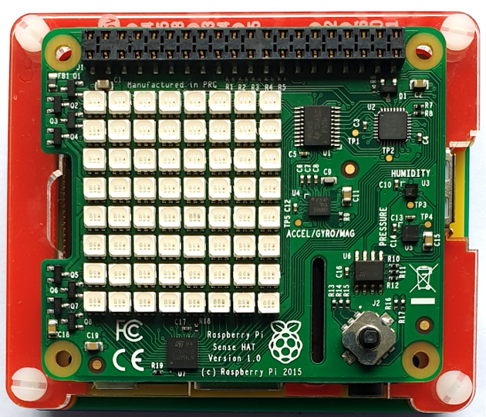

Raspberry Pi with SSD

* [Multi-User Set Up](https://github.com/gloveboxes/PyLab-0-Raspberry-Pi-Set-Up/tree/master/setup-multiuser/README.md)

The Multi-user set up allows up to 20 users/students per Raspberry Pi 4 4GB. A USB3 SSD drive is required to support the disk IO requirements for this number of users. The installation script installs the lab content, and Docker. Builds the lab Docker Images, and sets up all the users.

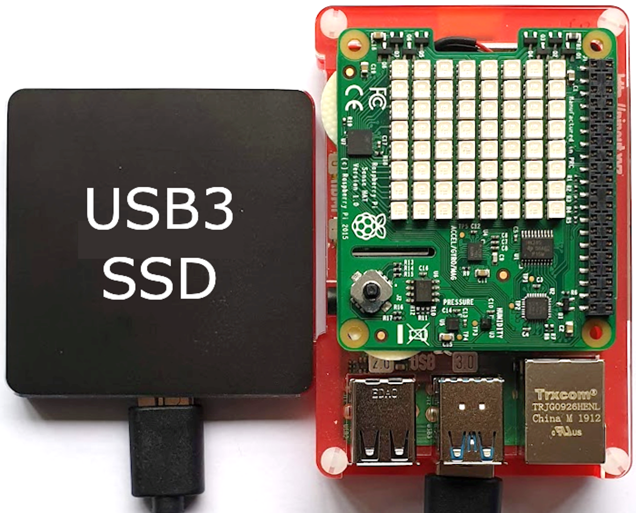

Raspberry Pi with SSD

## Software Installation



set up requirements

This hands-on lab uses Visual Studio Code. Visual Studio Code is a code editor and is one of the most popular **Open Source** projects on [GitHub](https://github.com/microsoft/vscode). It runs on Linux, macOS, and Windows.

### Install Visual Studio Code

1. **Install** [**Visual Studio Code**](https://code.visualstudio.com/Download?WT.mc_id=pycon-blog-dglover)

#### Visual Studio Code Extensions

The features that Visual Studio Code includes out-of-the-box are just the start. VS Code extensions let you add languages, debuggers, and tools to your installation to support your development workflow.

#### Browse for extensions

You can search and install extensions from within Visual Studio Code. Open the Extensions view from the Visual Studio Code main menu, select **View** > **Extensions** or by clicking on the Extensions icon in the **Activity Bar** on the side of Visual Studio Code.



Extensions view icon

This will show you a list of the most popular VS Code extensions on the [VS Code Marketplace](https://marketplace.visualstudio.com/VSCode?WT.mc_id=pycon-blog-dglover).

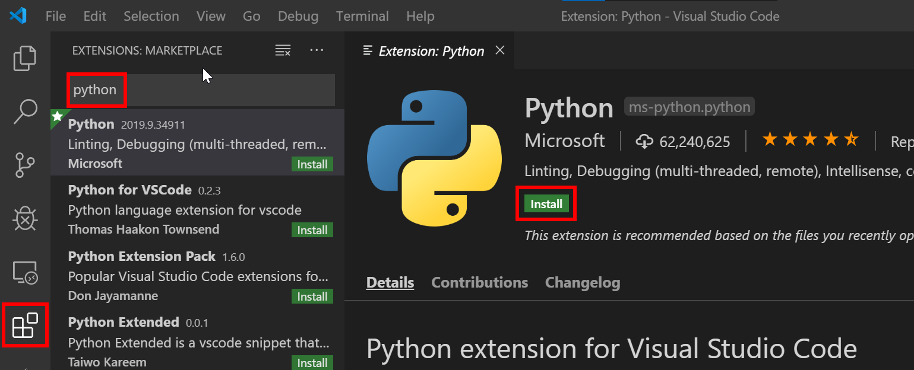

vs code install extension

### Install the Python and Remote SSH Extensions

Search and install the following two Visual Studio Code Extensions published by Microsoft.

1. [**Python**](https://marketplace.visualstudio.com/items?itemName=ms-python.python&WT.mc_id=pycon-blog-dglover)
2. [**Remote - SSH**](https://marketplace.visualstudio.com/items?itemName=ms-vscode-remote.remote-ssh&WT.mc_id=pycon-blog-dglover)

## Remote SSH Development

The Visual Studio Code Remote - SSH extension allows you to open a remote folder on any remote machine, virtual machine, or container with a running SSH server and take full advantage of Visual Studio Code.

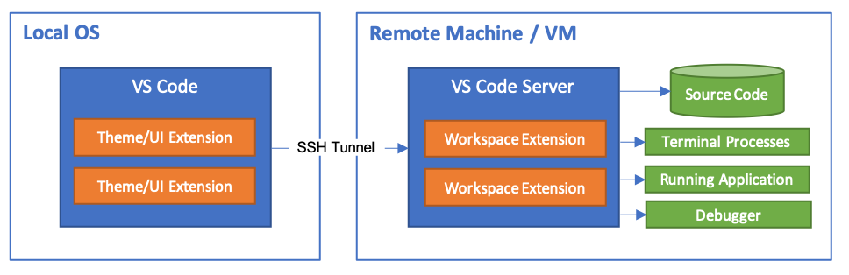

Architecture Diagram

## Raspberry Pi Hardware

If you are attending a workshop, then you can use a shared network-connected Raspberry Pi. You can also use your own network-connected Raspberry Pi for this hands-on lab.

You will need the following information from the lab instructor.

1. The **Network IP Address** of the Raspberry Pi
2. Your assigned **login name** and **password**.

## SSH Authentication with private/public keys



ssh login

Setting up a public/private key pair for [SSH](https://en.wikipedia.org/wiki/Secure_Shell) authentication is a secure and fast way to authenticate from your computer to the Raspberry Pi. This is recommended for this hands-on lab.

### SSH Set up for Windows Users

The SSH utility guides you through the process of setting up a secure SSH channel for Visual Studio Code and the Raspberry Pi.

You will be prompted for:

* The Raspberry Pi Network IP Address,
* The Raspberry Pi login name and password

1. From **Windows File Explorer**, open **ftp://<Raspberry Pi Address>**

* 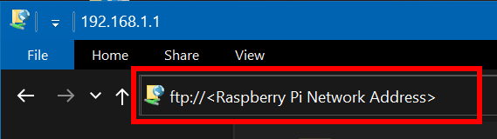

1. Copy the **scripts** directory to your **desktop**

* 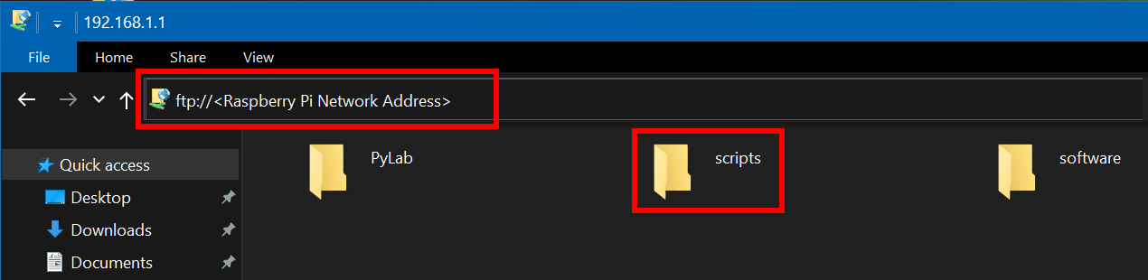
* Windows File Manager

1. Open the **scripts** folder you copied to your **desktop**
2. Double click the **windows-setup-ssh.cmd**

### SSH Set up for Linux and macOS Users

The SSH utility guides you through the process of setting up a secure SSH channel for Visual Studio Code and the Raspberry Pi

You will be prompted for:

* The Raspberry Pi Network IP Address,
* The Raspberry Pi login name and password

1. Open a Terminal window
2. Copy and paste the following command, and press **ENTER**

* read -p "Enter the Raspberry Pi Address: " pyurl && \  
  curl ftp://$pyurl/scripts/ssh-setup.sh | bash

## Start a Remote SSH Connection

1. **Start Visual Studio Code**
2. Press **F1** to open the Command Palette, type **ssh connect** and select **Remote-SSH: Connect to Host**
3. Select the **pylab-devnn** configuration

* 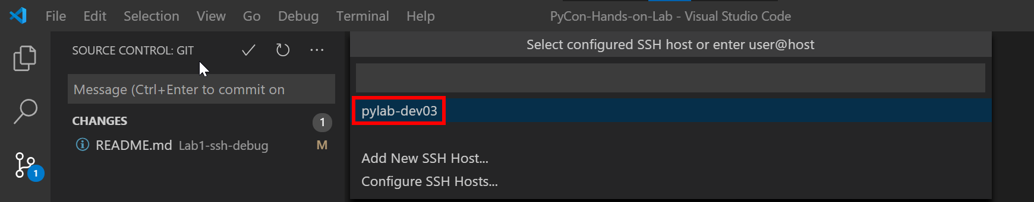
* open the ssh project

1. Check the Remote SSH has connected.

* It will take a moment to connect, then the SSH Status in the bottom lefthand corner of Visual Studio Code will change to **>< SSH:pylab-devnn**. Where devnn is your Raspberry Pi Login name.
* 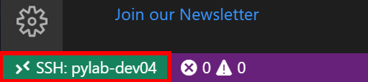

## Open PyLab 1 Python Debug Project

### Python Flask Web Apps

In this lab, we are going to start and debug a [Flask](https://www.fullstackpython.com/flask.html) app that reads a sensor attached to the Raspberry Pi. Flask is a popular Python Web Framework, powerful, but also easy for beginners.

1. From Visual Studio Code main menu: **File** > **Open Folder**
2. Select the **PyLab** directory

* 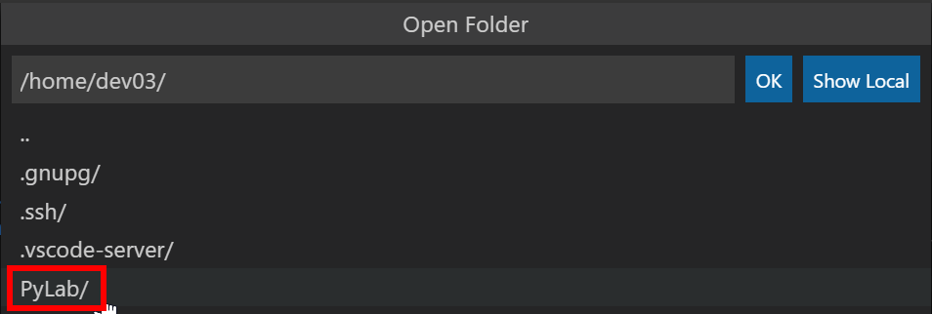

1. Next select, the **PyLab-1-Python-Debug** directory

* 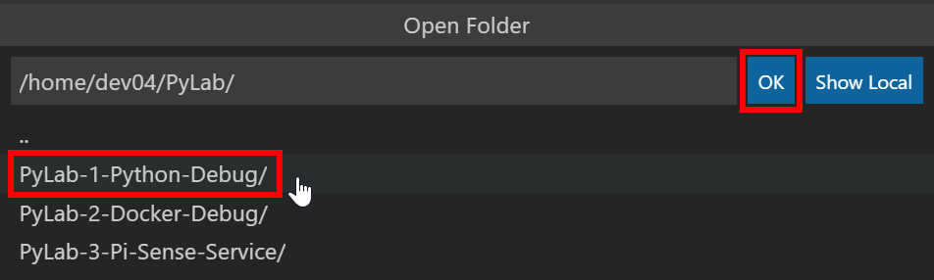

1. Click **OK** to Open the directory
2. From the **Explorer** bar, open the **app.py** file and review the contents

* 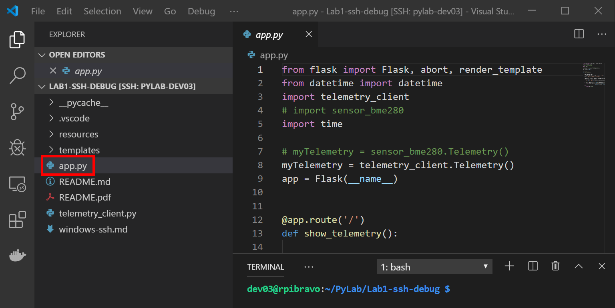

Take a moment to review the Python Flask web app.

#### app.py

from flask import Flask, abort, render_template  
from datetime import datetime  
import telemetry_client  
# import sensor_bme280  
import time  
  
# myTelemetry = sensor_bme280.Telemetry()  
myTelemetry = telemetry_client.Telemetry()  
app = Flask(__name__)  
  
  
@app.route('/')  
def show_telemetry():  
  
 now = datetime.now()  
 formatted_now = now.strftime("%A, %d %B, %Y at %X")  
  
 title = "Raspberry Pi Environment Data"  
  
 temperature, pressure, humidity, timestamp, cpu_temperature = myTelemetry.measure()  
  
 sensor_updated = time.strftime(  
 "%A, %d %B, %Y at %X", time.localtime(timestamp))  
  
 if -40 <= temperature <= 60 and 0 <= pressure <= 1500 and 0 <= humidity <= 100:  
 return render_template('index.html', title=title,  
 temperature=temperature, pressure=pressure,  
 humidity=humidity, cputemperature=cpu_temperature)  
 else:  
 return abort(500)

## Start the Python Flask App

1. Press **F5** to start the Python Flask app.
2. From the Visual Studio Code **Terminal Window**, click the **running on http://…** web link.

* 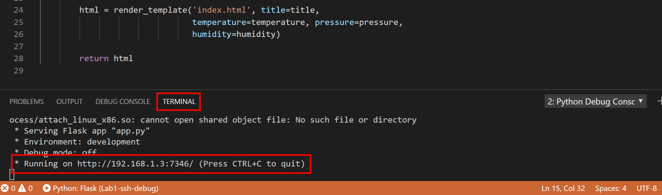
* Open web browser from VS Code

1. This will launch your desktop Web Browser.
   * The Flask app will read the temperature, air pressure, humidity from the **sensor** attached the Raspberry Pi and display the results in your web browser.

* 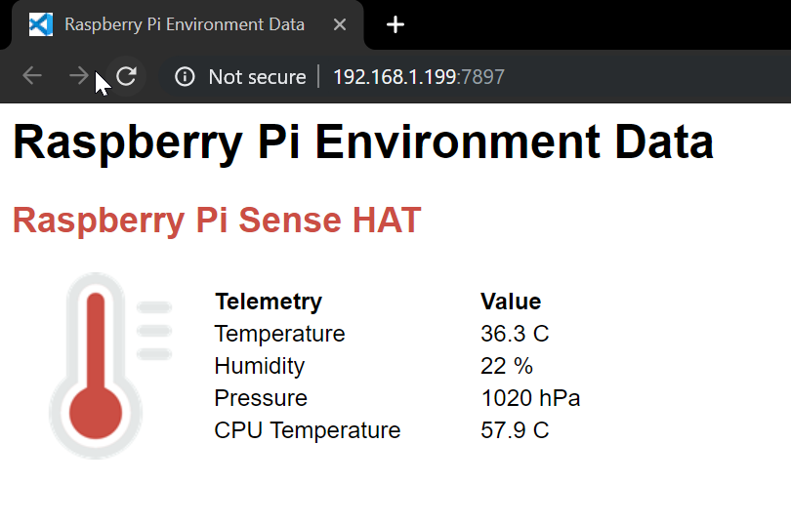
* Flask Web Page

## Debugging with Breakpoints

1. Switch back to Visual Studio Code and ensure the **app.py** file is open.
2. Put the cursor on the line that reads **now = datetime.now()**
3. Press **F9** to set a breakpoint. A red dot will appear on the line to indicate a breakpoint has been set.

* 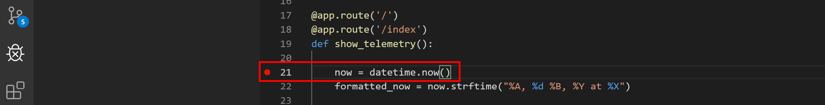
* Start the flask web application

1. Switch back to the **Web Browser** and click **Refresh**. The web page will **not respond** as the debugger has stopped at the breakpoint you set.
2. Switch back to **Visual Studio Code**. You will see that the code has stopped running at the **breakpoint**.

* 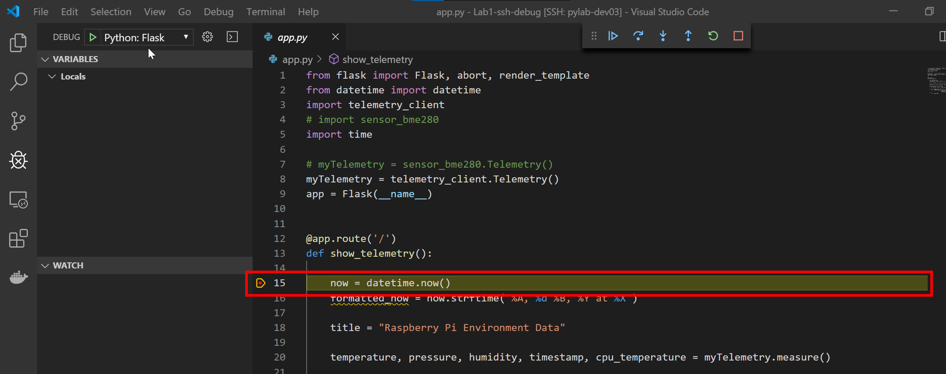

## Debugger Toolbar Options

When a debug session starts, the **Debug toolbar** will appear at the top of the editor window.

The debugging toolbar (shown below) will appear in Visual Studio Code. It has the following options:

Debug Actions

Debug Actions

1. Pause (or Continue, F5),
2. Step Over (F10)
3. Step Into (F11),
4. Step Out (Shift+F11),
5. Restart (Ctrl+Shift+F5),
6. and Stop (Shift+F5).

## Start Debugging

1. Step through the code by pressing (**F10**) or clicking **Step Over** on the debugging toolbar.
2. **Repeat** pressing **F10** until you reach the line that reads **if -40 <= temperature <= 60 and 0 <= pressure <= 1500 and 0 <= humidity <= 100:**
3. You will notice that Python variables are displayed in the **Variables Window**.

* If the Variable Window is not visible click **Debug** in the activity bar.
* 
* 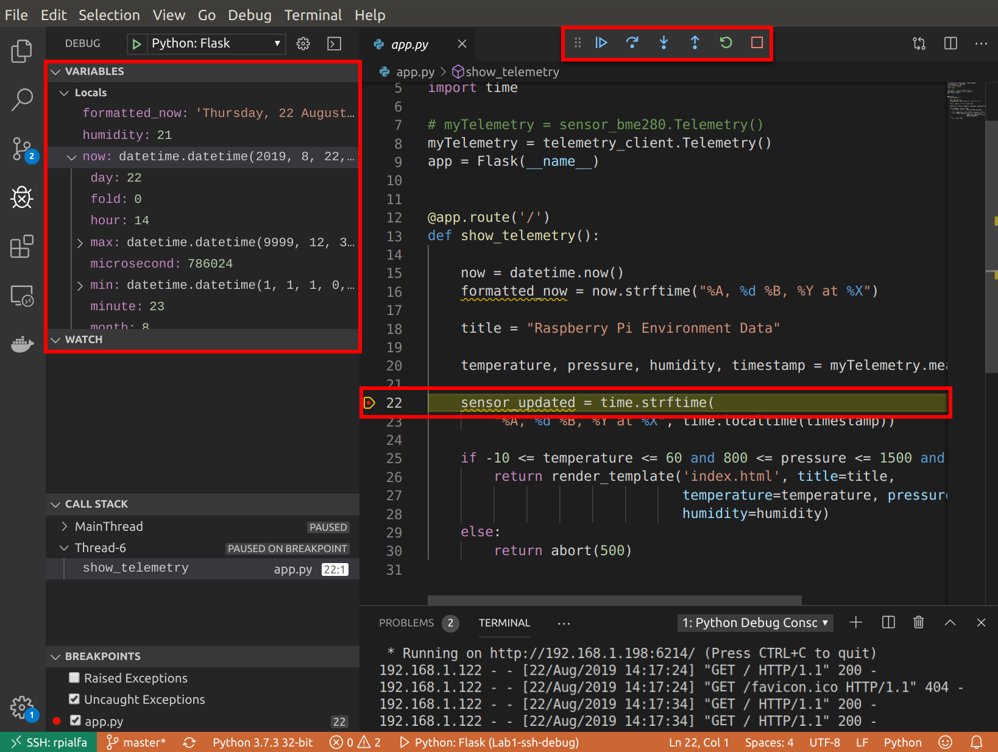
* Variable window

1. Try to change the **temperature** variable to **50**. Hint, **right mouse** click on the temperature variable and select **Set Value**, or double click on a **temperature** variable.
2. Press **F5** to resume the Flask App, then **switch back to your web browser** and you will see the temperature, humidity, and pressure Sensor data displayed on the web page.

### Debugging with Conditional Breakpoints

Try setting a **conditional** breakpoint

1. Clear the existing breakpoints. From the main menu select **Debug** > **Remove all breakpoints**.
2. Ensure the **app.py** file open.
3. **Right mouse click** directly in the margin to the **left** of the line number **22**.

* 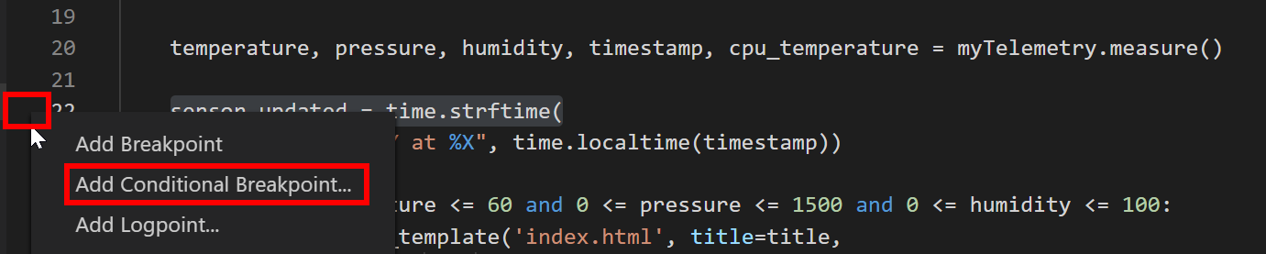

1. Select **Add Conditional Breakpoint…**
2. Set the condition to **temperature > 25**, then press **ENTER**

* 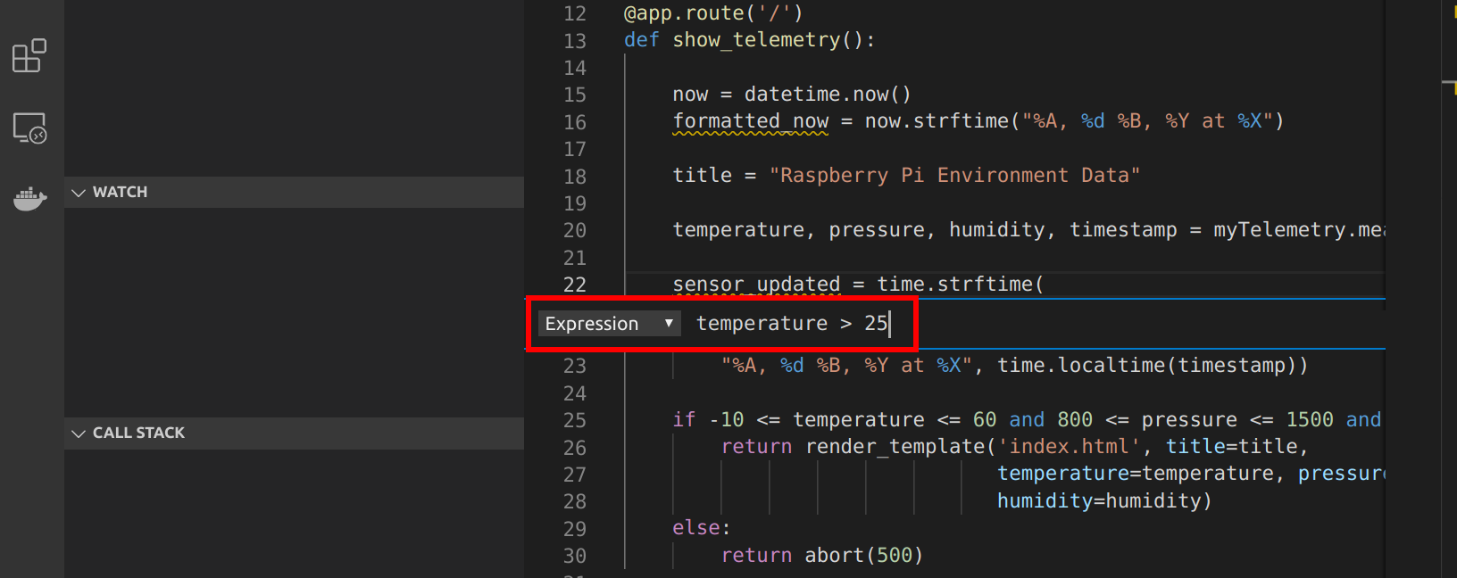
* Conditional BreakPoint in Visual Studio Code
* The breakpoint appears as a red dot with an equals sign in the middle

1. Switch back to the **Web Browser** and click **Refresh**. The web page will **not respond** as the debugger has stopped at the breakpoint you set.
2. **Switch** back to **Visual Studio Code** and you will see the debugger has stopped at the **conditional breakpoint**.
3. Press **F5** to continue running the code
4. **Switch** back to your **web browser** to view the page.

## Interactive Debug Console

The Visual Studio Code **Debug Console** will give you access to the [Python REPL](https://en.wikipedia.org/wiki/Read%E2%80%93eval%E2%80%93print_loop) (Read, Evaluate, Print Loop).

1. **Switch** back to your **web browser** and click refresh. The web page will **not respond** as the Python code has been stopped by the debugger.
2. **Switch** back to **Visual Studio Code**
3. The code will have stopped at the conditional breakpoint you previously set.
4. Select the Visual Studio **Debug Console** window.

* 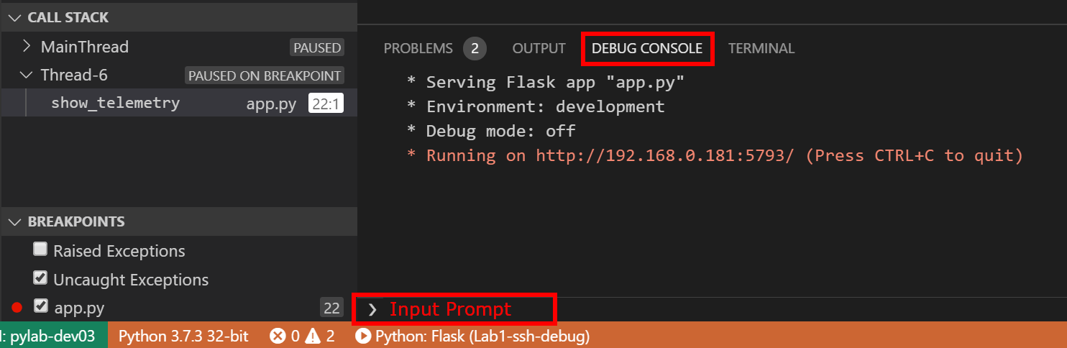
* visual studio debug console

1. Type the following Python code into the Input Prompt **>**

* print(temperature)

1. Press **Enter** to execute the Python code you typed.
2. Try running the following Python code snippets from the input prompt.

* temperature = 24  
  import random  
  random.randrange(100, 1000)

1. Press **F5** to continue the execution of the Python code.
2. Switch back to you web browser to see the updated page.

## Lab Challenges

### Lab Challenge 1: Update the Flask Template

1. Update the Flask **index.html** template found in the **templates** folder to display the current date and time.
2. Rerun the Flask app.

### Lab Challenge 2: Experiment with Debugger Options

Things to try:

1. Review the [Visual Studio Code Python Tutorial](https://code.visualstudio.com/docs/python/python-tutorial?WT.mc_id=pycon-blog-dglover)
2. Review the [Python Flask tutorial](https://vscode-westeu.azurewebsites.net/docs/python/tutorial-flask)
3. Review the [Visual Studio Code Debugging Tutorial](https://code.visualstudio.com/docs/editor/debugging?WT.mc_id=pycon-blog-dglover)

## Review the Debug **Launch** Settings

1. Switch to Debug view in Visual Studio Code (using the left-side activity bar).

* 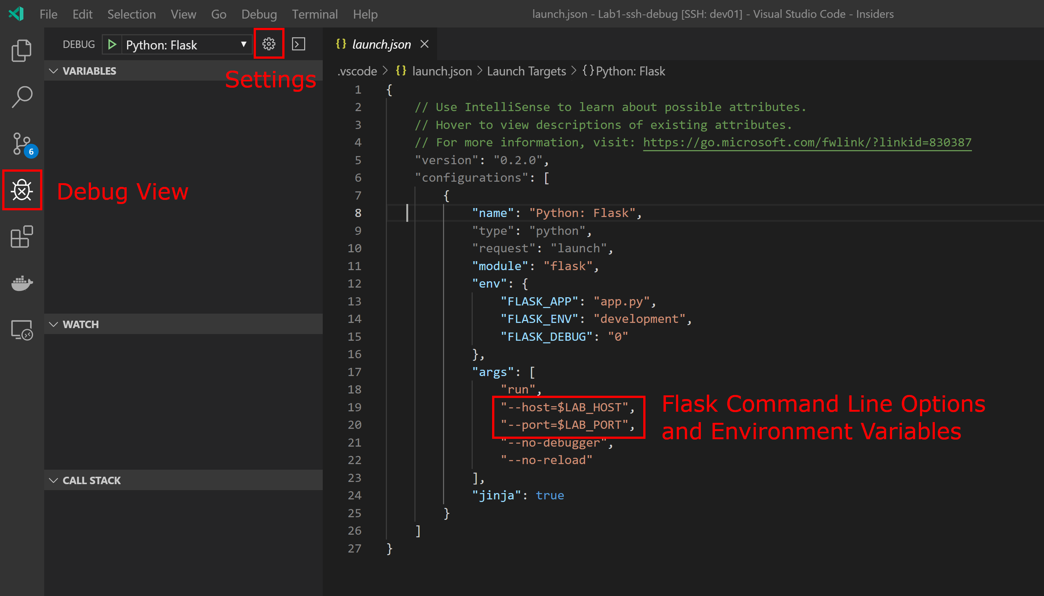
* open launch json file

1. Click the **Settings** button which will open the **launch.json** file.
2. The **launch.json** file defines how the Flask app will start, and what [Flask Command Line](https://flask.palletsprojects.com/en/1.0.x/cli/) parameters to pass at startup.

* There are two environment variables used in the launch.json file. These are **LAB_HOST** (which is the IP Address of the Raspberry Pi), and **LAB_PORT** (a random TCP/IP Port number between 5000 and 8000). These environment variables are set by the .bashrc script which runs when you connect to the Raspberry Pi with Visual Studio Remote SSH.

## Closing the Remote SSH Session

From Visual Studio Code, **Close Remote Connection**.

1. Click the **Remote SSH** button in the **bottom left-hand corner** and select **Close Remote Connection** from the dropdown list.

* 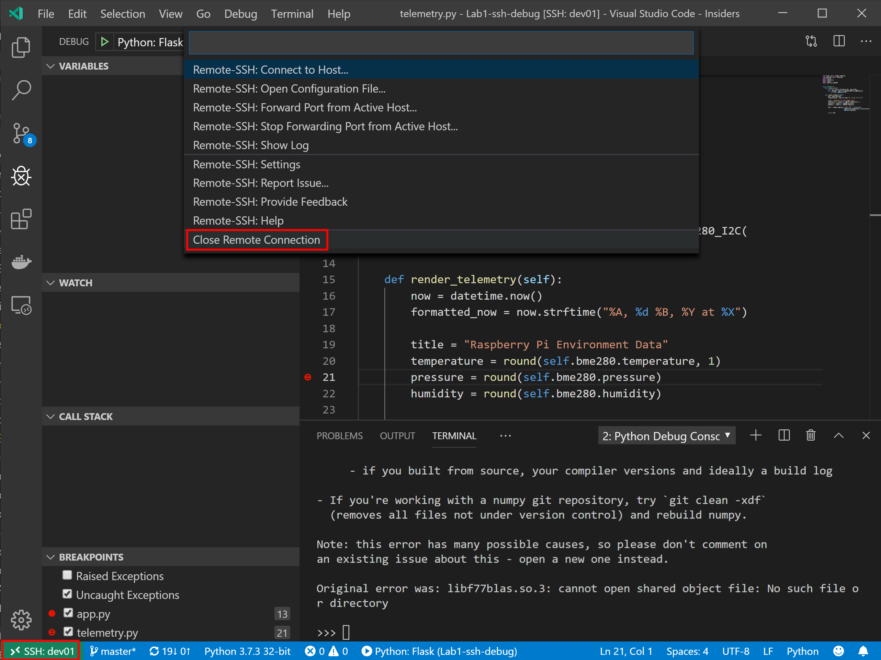
* close Remote SSH

## Finished



finished

## References

* [Visual Studio Code](https://code.visualstudio.com/?WT.mc_id=pycon-blog-dglover)
* [Python](https://www.python.org/)
* [Raspberry Pi](https://www.raspberrypi.org/)
* [Flask](https://www.fullstackpython.com/flask.html)

## Trouble Shooting SSH Client Installation

* [Remote Development using SSH](https://code.visualstudio.com/docs/remote/ssh?WT.mc_id=pycon-blog-dglover)
* [Installing a supported SSH client](https://code.visualstudio.com/docs/remote/troubleshooting#_installing-a-supported-ssh-client?WT.mc_id=pycon-blog-dglover)